**Administrative Guide for MEASURE**

Faculty of Engineering, McMaster University

November 8, 2022

**by**

Evan Situ, Michelle Zheng, Spencer Smith, Andrew Aran, Nicholas Lam

**Modification Log**

|  |  |  |  |
| --- | --- | --- | --- |
| **Version** | **Modification Date** | **Author** | **Comments** |
| 3.02 | November 8, 2022 | Andrew Aran | * Update instructions for Updating Courses & Program Maps |
| 3.01 | July 30, 2021 | Andrew Aran & Nicholas Lam | * Updated archiving process * Updated instructions for accessing Annual & YoY Attribute reports * Added Updating Courses & Program Maps * Added Measured Indicators |
| 3.00 | January 9, 2020 | Andrew Aran | * Initial Draft |

Click here to view previous modification log.

Table of Contents

Introduction 5

Prerequisites 6

Vena Administrative Rights 6

Windows 6

System Requirements 6

About the Vena Add-In 6

Installing Vena Add-In for Windows Users 6

Enabling Trust Access to the VBA Project Object Model 7

Other Operating Systems 9

Instructions to Access a Virtual Machine: 9

Questions/Comments/Technical Support: 9

Annual Timeline 10

Ad hoc Tasks 11

Accessing Vena 12

Changing Vena Password 12

New Academic Year Process 12

Vena Academic Cycle 13

Archiving Vena Data 13

Historical Program Measurement Archive 13

Starting a New Academic Year 15

Updating Global Variable 17

Review Archived Data 19

Announcements 20

Faculty Recommendations Template 20

Backup and Restore Process 21

Disaster Recovery Flow Chart 22

Ad hoc Tasks 22

User Management 22

Adding a User 23

Updating User Information 23

Removing a User 24

Assigning User to a Process 24

Versioning 25

Measured Indicators 26

Opening the Measurement Mapping 26

Updating the Measurement Map 27

Cascade 28

Generating a Mass Course Report 28

Force Check-In 29

Unsubmit 30

CourseList – Rubric Input Template 30

Updating the CourseList 30

Updating Courses & Program Maps 33

Adding a New Course 34

Sharing a Course 35

Un-mapping a Course 36

Reports 37

Accessing the Reports 38

CEAB Annual Attribute Report 38

CEAB YoY (Year over Year) Attribute Report 40

Maintaining the CEAB Attribute Reports 40

Rubric Entry Report 43

Faculty and Curriculum Committee Recommendations Report 43

Attribute Map Report 44

Attribute Map Summary Report 45

Indicator Map Report 45

Historical Course Measurement Report 46

Historical Program Measurement Report 47

Course Report 47

Appendix I: Calculating the CEAB Annual Attribute Reports 49

How the Graduate Attribute Values are Normalized 49

How the Average Scores are Calculated 49

Appendix II: Previous Modification Log 50

# Introduction

The Administrative Guide is part of MEASURE (McMaster Engineering Accreditation System for UndeRgraduatE).

MEASURE’s purpose is to:

* Facilitate the continual improvement of the curriculum of the programs offered by the Faculty of Engineering
* Assist with generating accreditation reports for the Canadian Engineering Accreditation Board (CEAB)

MEASURE is built using corporate performance management software, (Vena) that combines Excel spreadsheets, a central database, and workflow management.

This document outlines the MEASURE tasks that take place at the faculty level. Specifically, the Office of the Dean will update the following:

* Adding Users
* Updating passwords
* Archiving data
* Creating new academic year
* Creating/Updating reports (where applicable)
* Providing technical support

Additional information on MEASURE can be found in the Instructor’s Guide and Department Guide. The latest version of all these documents, along with other resources, are available at <http://measure.mcmaster.ca>

Issue Reporting: <https://www.eng.mcmaster.ca/forms/measure-issue-tracking>

Technical Support: [measure@mcmaster.ca](mailto:measure@mcmaster.ca)

# Prerequisites

Administrator functionality is currently compatible for Vena users with Windows operating system. Enhancements will be implemented by Vena in the future to enable macOS compatibility.

## Vena Administrative Rights

Vena Administrative rights will be required for…

* User management
* Creating and running ETL (Extract, Transform, and Load) processes
* Archiving accreditation data
* Creating new academic years
* Creating and updating Vena templates and reports

To request access, contact <measure@mcmaster.ca>.

## Windows

### System Requirements

|  |  |  |
| --- | --- | --- |
|  | **Recommended** | **Minimum** |
| **Operating System** | Latest version of Windows 10 (64-bit) | Windows 7 (32-bit) |
| **MS Office** | Office 2016 or newer   * Click [here](https://www.mcmaster.ca/uts/licensing/msemployees.html) for instructions to download Office (via UTS) | Office 2010 |
| **.NET** | Latest version of .NET | 4.5 |
| **Browser** | Latest version of:   * Internet Explorer * Microsoft Edge * Mozilla Firefox * Google Chrome | * Internet Explorer 10+ * Microsoft Edge * Mozilla Firefox 12.0+ * Google Chrome |
| **RAM** | 16 GB | 4 GB |
| **CPU** | 2+ Cores | -- |
| **Reference:** | <https://support.venasolutions.com/hc/en-us/articles/115000622006-Vena-Add-In-System-Requirements> | |

### About the Vena Add-In

Vena uses both Microsoft Excel and the Vena website (<https://vena.io>) to give users access to the various templates and accreditation reports. Before users can update their course data in Excel, they will need to install the Vena Add-In for Microsoft Excel. This Add-In provides functionality to Excel that allows users to view, edit, and save their rubric data to the Vena cloud.

### Installing Vena Add-In for Windows Users

1. Visit the add-in website <http://addin.vena.io/release/vena.application>
2. Save the **vena.application** file
3. Double-click the **vena.application** file



1. Run the installer. The following dialog box will appear:

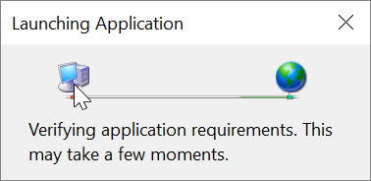

1. When the application has loaded, press **Install**

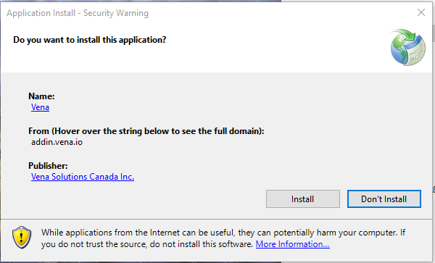

1. When the installation has completed, the following dialog box will appear. **Close** this dialog box to complete the installation.

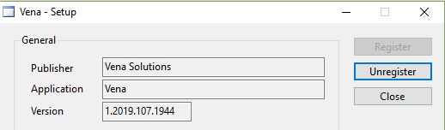

1. To ensure Vena has successfully installed, open Microsoft Excel, and confirm the Vena tab has been added.

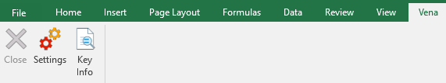

### Enabling Trust Access to the VBA Project Object Model

After installing the Excel Vena Add-in, access to the VBA project object model will need to be trusted for Vena to run properly.

1. Open **Excel**
2. Select a **Blank Workbook**
3. Select **File**

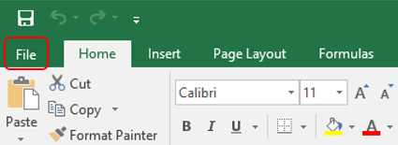

1. On the bottom of the left menu, select **Options**

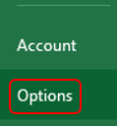

1. Select **Trust Center**
   1. Select **Trust Center Settings**

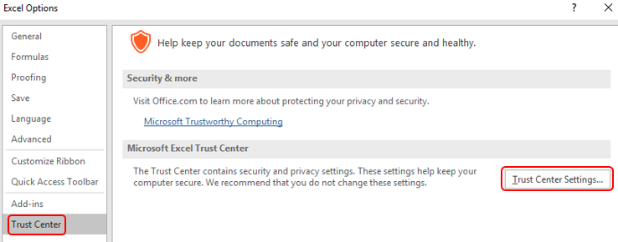

1. Select **Marco Settings**
2. Ensure that **Disable all macros with notification** is selected
3. Check the box next to **Trust access to the VBA project object model**

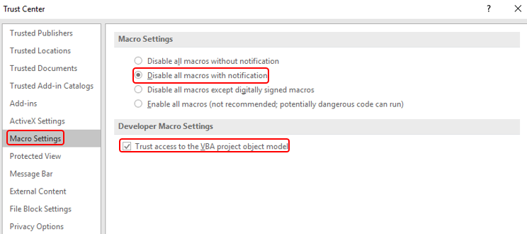

1. Close all instances of Excel for the settings to take effect.

## Other Operating Systems

Administrator functionality is currently compatible for Windows users with Microsoft Office. Users who do not have a compatible operating system and/or Microsoft Office will need to access Vena using a virtual machine.

### Instructions to Access a Virtual Machine:

<https://www.eng.mcmaster.ca/sites/default/files/vminstruct.pdf>

### Questions/Comments/Technical Support:

[measure@mcmaster.ca](mailto:measure@mcmaster.ca)

# Annual Timeline

The table below summarizes the typical tasks performed during an academic year.

The Administrator’s responsibilities are highlighted in **green**.

The timeline table shows an entry for adding courses, but no time slot for deleting courses that are no longer offered. This is because courses are not deleted, since deleting them will remove all of the historical data associated with the course. Courses can be removed from a specific program, but should not be removed from the Vena database. Courses that are no longer offered should be moved to the unmapped folder, as described in the Departmental Guide.

|  |  |  |  |  |
| --- | --- | --- | --- | --- |
| **Date** | **Task Description** | **Section** | **Template** | **Task Owner** |
| January | * Instructor enters rubric and continuous improvement plan for Term 1 | Instructor Guide | Rubric Input Template | Instructor |
| January | * Instructor reviews the continuous improvement plan from the previous year for Term 1 | Instructor Guide | Rubric Input Template and Curriculum Committee Recommendations Report (Prev. Year) | Instructor |
| January | * Review current rubric entry status * Contact instructors who have yet to complete their Vena rubric entry | Department Guide | Rubric Entry Report | Department |
| April | * Update global variable and point to Term 2 (after Term 1 data entry is complete) | Click here | Input Variables Template | Associate Dean’s Office |
| May | * Instructor enters rubric and continuous improvement plan for Term 2 | Instructor Guide | Rubric Input Template | Instructor |
| May | * Instructor reviews continuous improvement plan from the previous year for Term 2 | Instructor Guide | Rubric Input Template and Curriculum Committee Recommendations Report (Prev. Year) | Instructor |
| May | * Review current rubric entry status * Contact instructors who have yet to complete their Vena rubric entry | Department Guide | Rubric Entry Report | Department |
| May | * Curriculum committees review (this year) course reports and continuous improvement plan reports | Department Guide | Course Report and  Rubric Input Template (Instructor Guide) | Department |
| August | * Archive previous year | Click here | Archive Data (ETL) | Associate Dean’s Office |
| * Start New Academic Year | Click here | New Academic Year (ETL) |
| * Update global variable and point to Term 1 (after Term 2 data entry is complete) | Click here | Input Variables Template |
| August | * Update Measurement Mapping | Department Guide | Measured Indicators Input Template | Department |
| August | * Update Curriculum Mapping   + Consult with Instructors | Department Guide | Curriculum Mapping Input Template | Department |
| August | * Update Curriculum Recommendations | Department Guide | Curriculum Committee Recommendations Input Template | Department |
| August | * Review Programs in Vena * Notify Associate Dean’s Office if changes are needed | Department Guide | Login Vena🡪 Modeler🡪 Members🡪 Program | Department |
| August | * Add/Update/Un-map courses in the Vena Database * **Do not delete Courses** | Department Guide | Login Vena🡪 Modeler🡪 Members🡪 Program | Department |
| September | * Faculty reviews departmental continuous improvement plan report from previous year * Prepare/review Graduate Attribute Report | Click here | Faculty Recommendations Template | Associate Dean’s Office |
| December | * Execute Backup and Restore Process | Click here |  | Associate Dean’s Office |

## Ad hoc Tasks

Below is a list of ad hoc tasks the Vena Administrator would execute throughout the year.

|  |  |  |
| --- | --- | --- |
| **Task Name** | **Task Description** | **Section** |
| Manage Vena Users | * Add, remove, update users | Click Here |
| * Assigning users to a process | Click Here |
| Versioning | * A versatile feature that allows you to copy data from one portion of your database and write it to another portion * Helps to consolidate rubric data ([Reference](https://github.com/smiths/MEASURE/issues/251)) | Click Here |
| Measured Indicators | * The measurement map identifies what needs to be measured for each year | Click Here |
| Cascade | * This feature enables users to generate the same Vena report for multiple courses/programs   + I.e. Generate multiple Course Reports | Click Here |
| Force Check-Ins | * A template that has been checked out by a user who is unavailable and it needs to be checked back in | Click Here |
| Unsubmit | * This feature helps unsubmit a task if it has inadvertently been submitted | Click Here |
| Update Course List | * The Course List worksheet is updated when a course has been added, removed, or changed | Click Here |
| Updating Courses & Program Maps | * Add/edit/un-map courses from the program * Add/edit/un-map the program | Click Here |
| Reports | * Generate reports from the rubric data * Vena Administrators will also be able to create Excel-based charts to meet user needs (Refer to Vena Documentation)   + For support, contact [Vena Support](https://support.venasolutions.com/) | Click Here |

# Accessing Vena

1. Open a web browser
2. Visit <https://vena.io>
3. In the email textbox, enter your McMaster email address (i.e. [macid@mcmaster.ca](mailto:macid@mcmaster.ca))
4. Your password has been previously communicated. If you do not remember, or do not have an account, please contact Measure Support ([measure@mcmcaster.ca](mailto:measure@mcmcaster.ca))

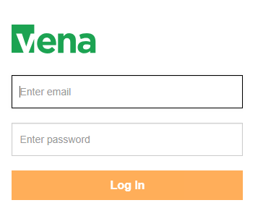

# Changing Vena Password

Your password can be changed by clicking the user’s name in the upper right corner of the screen and then selecting “Password” on the menu.

You will be prompted to enter the current and new password. The password must meet all password rules before it can be changed.

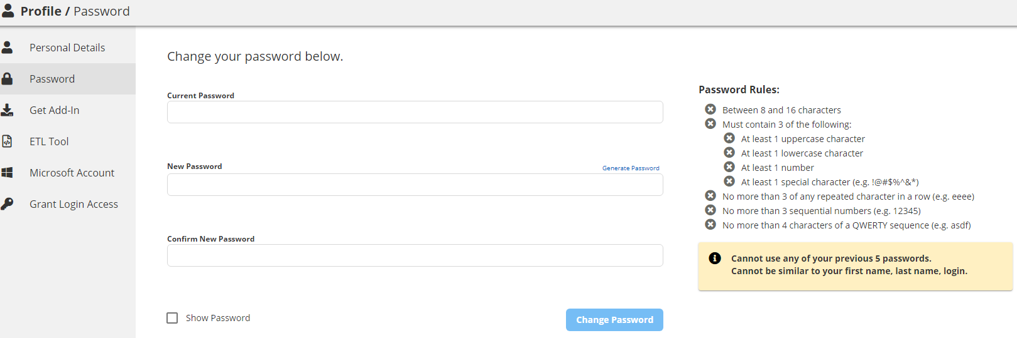

# New Academic Year Process

**NOTE**: Before executing the new academic year process (2021 and onwards), contact Andrew Aran ([arana2@mcmaster.ca](mailto:arana2@mcmaster.ca)) and Nicholas Lam ([nlam@venacorp.com](mailto:nlam@venacorp.com)).

At the end of every academic year, it is required to archive the rubric data for the year, create a new academic year, and evaluate the data to ensure data integrity is maintained.

The processes below will guide the Vena Administrator with supporting the academic cycle. For task tracking purposes, create a new project in GitHub: <https://github.com/smiths/MEASURE>.

## Vena Academic Cycle

## Archiving Vena Data

After rubric data has been entered for the year, the Vena Administrator will execute the Vena archiving process.

### Historical Program Measurement Archive

**Only archive the program measurement when the program is fully completed. The purpose of archiving the program measurement data is to track the historical trend of a program.**

**The purpose of archiving the data is so that the historical program measurement report can be generated.**

1. Ensure all Vena templates have been checked in.
   1. Login to <https://vena.io>
   2. Contributor 🡪 Inputs 🡪 “See More To Do Inputs”
   3. Confirm every template has checked in
      1. If a template is checked out, the user’s name will be listed below the template as “Checked Out”



1. If a template is checked out and the user who checked out the template is unavailable, a Force Check-In is required.
2. Submit the task.

Only the task owner has the ability to submit the task.

* 1. Contributor 🡪 Inputs 🡪 **Rubric Input & Course Report (by Instructor) –New**
  2. Click **Submit** 

1. Update the Academic Year Template
   1. Open the input template “AcademicYearTemplate.csv”
   2. Enter the academic year to archive in cell “A1” (format yyyy-yyyy)
      1. Example: If new academic year is 2020-2021, enter 2019-2020.
      2. 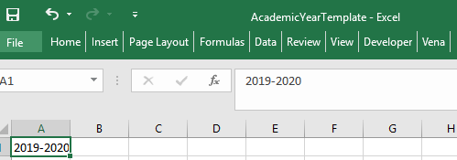
   3. **Save**
2. Run the Historical Program Measurement Archive ETL Job
   1. Modeler 🡪 Data Modeler 🡪 ETL 🡪 Templates 🡪 Run 
   2. Click **Choose File** and select the AcademicYearTemplate.csv file from Step 4.
   3. Click **Import**

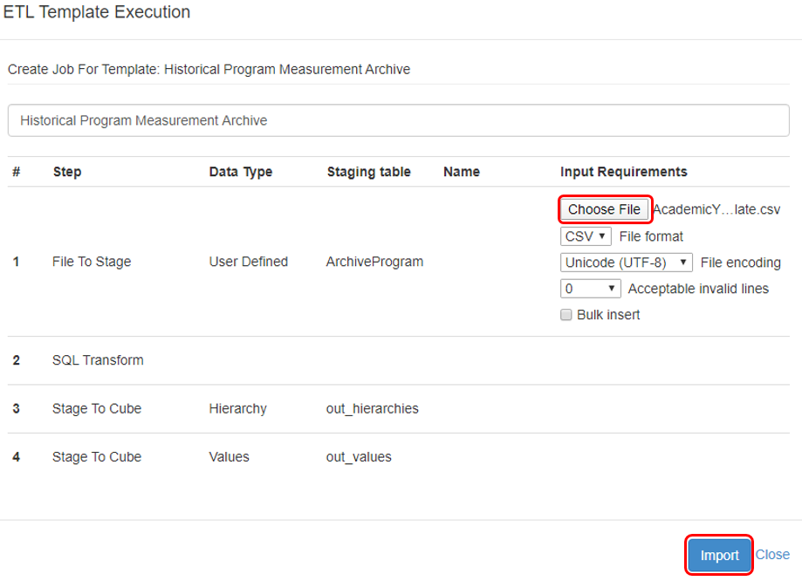

1. Reviewing ETL Job Status

The Historical Program Measurement Archive ETL Job will take approximately 5-10 minutes to complete.

* 1. To review the ETL Job status, Modeler 🡪 History 🡪**View Details** for Historical Program Measurement Archive

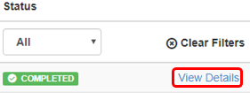

* 1. While running, the status will display **RUNNING**. When complete, the status will change to **Completed.**
  2. Click the  Refresh button for an updated ETL status.

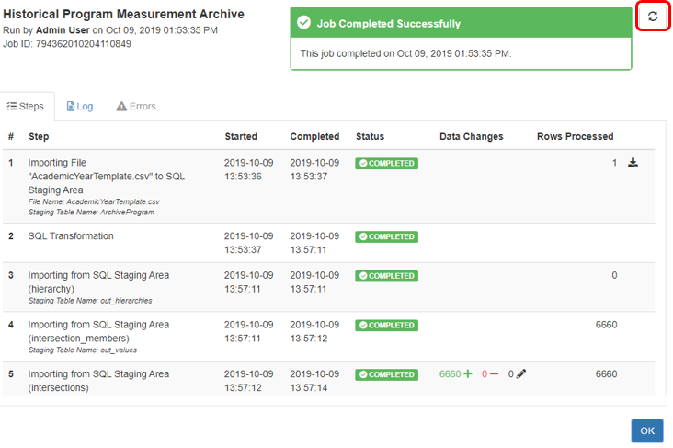

1. Historical Program Measurement Report

Once the archive is complete, the historical program data will be available in the Historical Program Measurement Report.

The historical program measurement report will not generate for any year’s data that has not yet been archived.

## Starting a New Academic Year

**Be sure to complete the Historical Program Measurement Archive Process before starting a new academic year.**

The current year’s curriculum mapping and rubric information will be used as the starting point for a new academic year. An automated ETL Job built by Vena will be executed to create the new academic year.

1. Update the Academic Year Template
   1. Open the input template “AcademicYearTemplate.csv”
   2. Enter the new academic year data in cell “A1” (format yyyy-yyyy)
      1. Example: If new academic year is 2019-2020, enter 2019-2020.
      2. 
   3. **Save**
2. Run the New Academic Year ETL Job
   1. Modeler 🡪 Data Modeler 🡪 ETL 🡪 Templates 🡪 Run 
   2. Click **Choose File** and select the AcademicYearTemplate.csv file from Step 4.
   3. Click **Import**

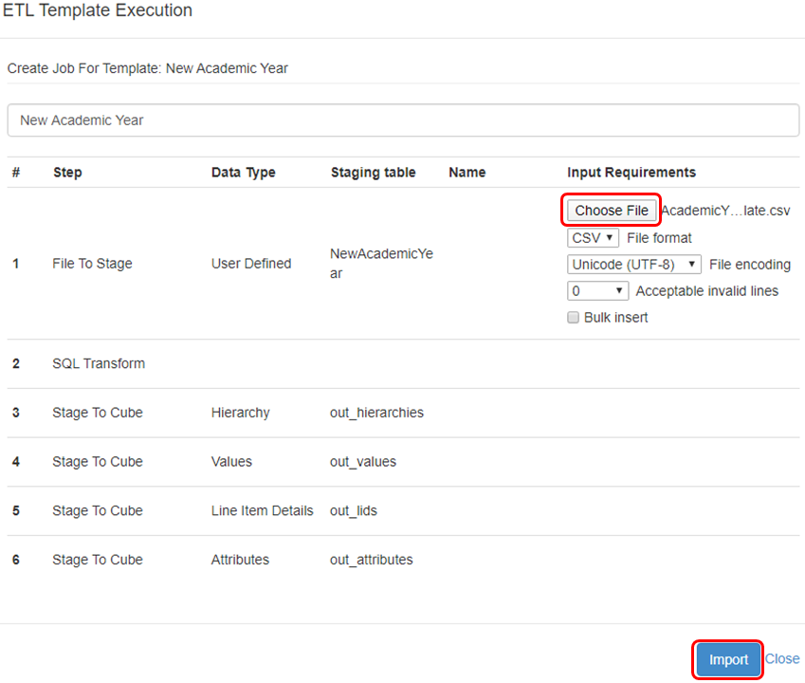

1. Reviewing ETL Job Status

The New Academic Year ETL Job will take approximately 5-10 minutes to complete.

* 1. To review the ETL Job status, Modeler 🡪 History 🡪**View Details** for New Academic Year



* 1. While running, the status will display **RUNNING**. When complete, the status will change to **Completed.**
  2. Click the  Refresh button for an updated ETL status.

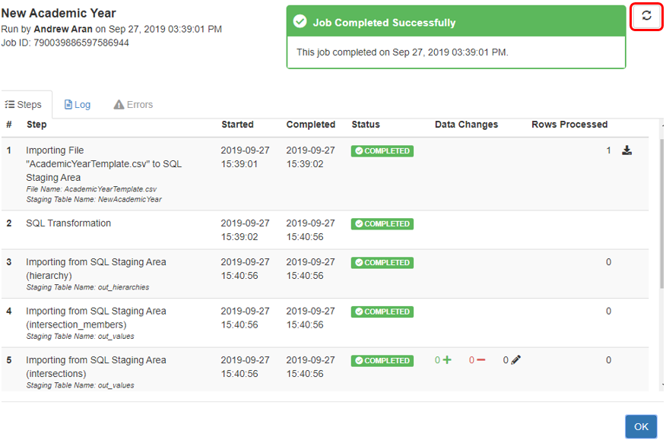

1. After the ETL Job is complete, the newly created academic year will appear under the Year Dimension
   1. Modeler 🡪 Year

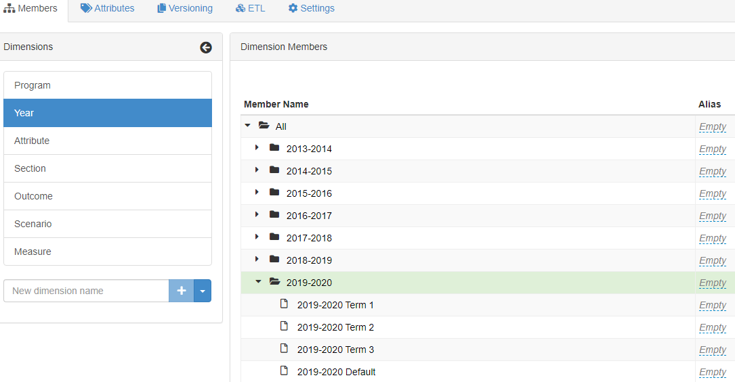

## Updating Global Variable

Below are the steps to successfully update a Global Variable. Updating the term global variable will prevent entering the incorrect term/year in the input templates.

1. Download the **Input Variables Template**
   1. Manager 🡪Home 🡪 Accreditation 2.0 🡪 Files Library 🡪 Input Forms 🡪 Data Controls 🡪 Input Variables Template.xlsx
2. Open the Input Variables Template
   1. Click **Enable Editing** if the pop-up appears
3. Change to Template Edit Mode
   1. If in Edit Data mode, switch to Template Edit mode by clicking Edit Template
      1. The button should toggle to display “Edit Data”

C:\Users\arana2\AppData\Local\Microsoft\Windows\INetCache\Content.Word\Capture.png🡪C:\Users\arana2\AppData\Local\Microsoft\Windows\INetCache\Content.Word\Capture.png

1. Update the Process Variable
   1. Select the cell with the value of the Global Variable

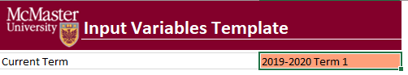

* 1. Click Add/Edit Variable 🡪 Process Variables 🡪 Add/Edit (must be in Edit Template mode)

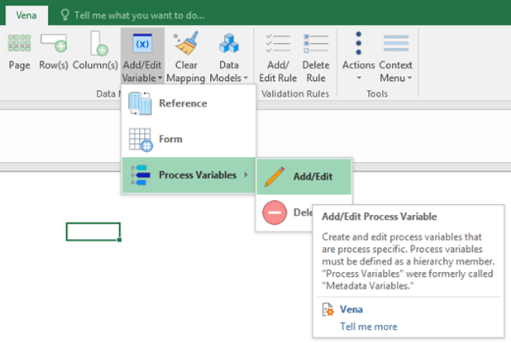

* 1. Update the respective variable with the new member
     1. Only a single member can be in a global variable

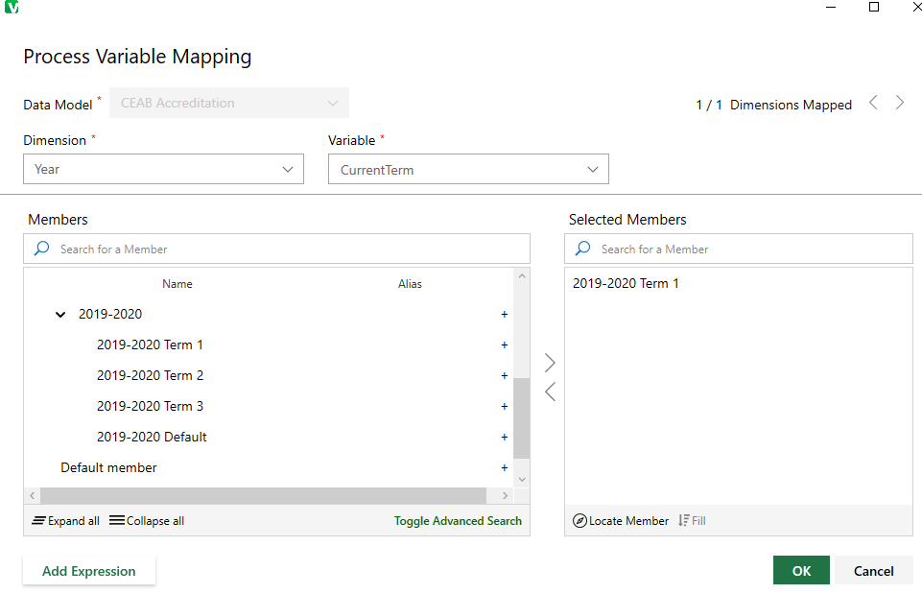

* 1. Close the variable window and Save Template.

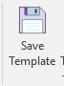

## Review Archived Data

After archiving the data, creating a new year, and pointing to a new term, it is recommended to generate and review the previous years’ reports and test the input templates before announcing the new academic year is available.

Generate and review the previous years’ reports to ensure rubric data is consistent:

* Historical Course Measurement Report.xlsm
* Historical Program Measurement Report.xlsm
* CEAB Attribute Report

Test Plan Reference: <https://github.com/smiths/MEASURE/issues/251>

|  |  |
| --- | --- |
| **Test Plan for the Vena Templates** | |
| **Template** | **Test Criteria** |
| Curriculum Committee Recommendations Input Template.xlsm | * Data entry/save is working as expected * Previous year data and attachments are available |
| Curriculum Mapping Input Template.xlsm | * Previous year mapping carried over to new year * New year mapping can be updated |
| Faculty Recommendations Input Template.xlsm | * Data entry/save is working as expected * Previous year data and attachments are available |
| Measured Indicators Input Template.xlsm | * Previous year mapping carried over to new year * New year mapping can be updated |
| Rubric Input Template.xlsm (Win & macOS) | * Data entry/save is working as expected * Learning outcomes carry over in correct sequence * Comments/Assumptions do not populate * Summary and Detailed View Reports are working as expected |
| Course Report.xlsm | * Summary/Detailed Chart button is working as expected |

Test Plan Reference: <https://github.com/smiths/MEASURE/issues/250>

## Announcements

After successfully testing the Vena reports and templates, send an email announcing data entry is available for the current term. This is also a good opportunity to provide any key updates such as new reports, bug fixes, due dates, etc.

# Faculty Recommendations Template

Faculty can share their recommendations by using the Faculty Recommendations Template. Once the recommendations are saved, they can be seen as a read-only report by generating the Faculty and Curriculum Committee Recommendations Report.

1. Login to <https://vena.io>
2. Contributor 🡪 Faculty Recommendations 🡪 **Check Out**  Faculty Recommendations Input Template.xlsm



1. Select the Year and click **OK**

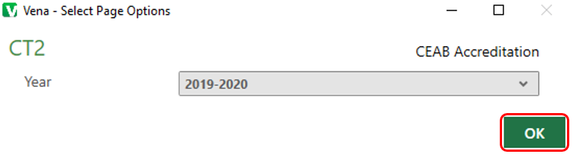

1. Recommendations can be entered as text in the Faculty Recommendations Vena Template or captured in a Word or PDF report. Therefore, there is an option to attach a file to the recommendations.
   1. To attach a file to your recommendations,
      1. Click the **Vena** Tab
      2. Click the empty section below the “Faculty Recommendations for 20XX-20XX”
      3. Click **Comments**
      4. In the Comments section, click **Details** Tab
      5. Click the **Add Comment** button



* + 1. Click the **Attach File** and attach your file
    2. Click **Upload** when asked to upload the file as a comment

When attaching a file as a comment, please write text in the associated field to let future readers know that additional information is available as a comment. Something similar to the following would be fine: “For additional information, please see report attached to this cell”.

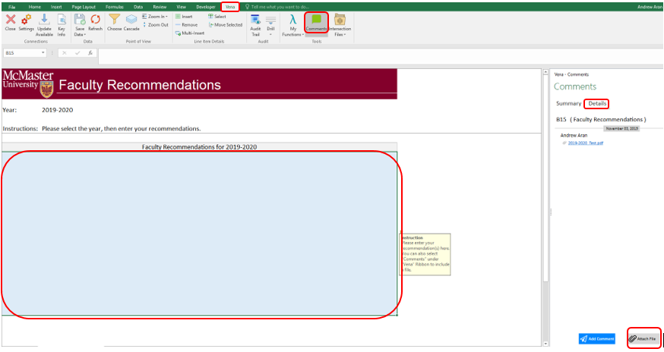

1. Click **Save Data** under **Vena** Tab and **Check in** the file

# Backup and Restore Process

The purpose of executing the backup and restore process is to ensure data integrity is maintained and data is recoverable in the event of an actual disaster.

1. The Administrator and Vena coordinate a date/time to create and test the DR (disaster recovery) environment.
2. Prior to creating the DR environment, the Administrator will record information from the production environment. This information will be used to compare with the DR environment.
3. Insert data – A copy of a template from the latest users to insert data
4. Update data – A copy of a template from the latest users to update data
5. Delete data – A copy of a template from the latest users to delete data
6. Users –A screenshot containing the current number of Vena users
7. ETL Jobs – A screenshot containing the ETL jobs and the last time they were executed

Click [here](https://github.com/smiths/MEASURE/issues/196) for reference and a sample test plan.

1. Vena notifies the Administrator the status of the DR environment.
2. If the DR environment is available, the Administrator will compare the data from step 2 with the DR environment.
3. If data from the DR environment is consistent with the production environment, the Backup and Restore Process was successful. Otherwise, review and notify Vena.
4. After testing, Vena destroys the DR environment and notifies the Administrator.

## Disaster Recovery Flow Chart



# Ad hoc Tasks

## User Management

The Vena Administrator has the ability to add, update, and remove users.

Here are the roles usually assigned to users. Users can be given elevated roles such as Modeler, but will need to be reviewed and approved by the Dean’s Office.

|  |  |  |
| --- | --- | --- |
| **User Type** | **Vena Role** | **Description** |
| Faculty/Staff | Contributor | Enter and submit rubric information |
| Department Representatives | Modeler | Read-only access to programs and measured indicators |
| EngIT Administrator | Super Users, Admins, Managers | Maintain MEASURE |

### Adding a User

1. Login to <https://vena.io>
2. Admin 🡪 Users 🡪 Add User
3. Fill in the user information and select the Login Type
   1. Default Login Type is **Contributor**
   2. Users can also be assigned as an Admin, Manager, Modeler, or Reports
4. Click **Save**

#### Vena User Group

After a user has been created, they will need to be added to a Vena User Group.

1. Login to <https://vena.io>
2. Admin 🡪 Permissions 🡪 User Group
3. Select a user group
   1. Default User Group is **Contributor** (unless stated otherwise)
   2. Users can also be assigned as an Admin, Manager, Modeler, or Reports

### Updating User Information

Vena Administrator’s have the ability to update existing user information such as their name, email, user role, user group and status.

1. Login to <https://vena.io>
2. Admin 🡪 Users
3. Search the user by name or email address
4. Once the user is found, click the value that requires updating
   1. Example: If the first name needs to be changed, click the value containing their first name
5. Update the value and press **Enter**

### Removing a User

1. Login to <https://vena.io>
2. Admin 🡪 Users
3. Search the user by name or email address
4. Right-click the user and select **Remove User**
5. Confirm when prompted

### Assigning User to a Process

Users will need to be assigned to a process to access the Vena Templates and Reports.

|  |  |
| --- | --- |
| **Vena Task Role** | **Description** |
| Owner | Will have permissions to enter data and also submit/review the task |
| Support Worker | Will only have the ability to enter data on the templates  Will not be able to submit or approve tasks) |
| Watcher | Will only be able to view the data in templates.  Will not have permission to enter data or submit/approve/reject tasks |

1. Login to <https://vena.io>
2. Manager 🡪 Process 🡪 Accreditation 2.0

If user is a **Faculty/Staff**, they will have access to the Rubric Input & Course Report Process.

1. Click **Rubric Input & Course Report Process**
2. Under the Support Worker Section, click the drop-down button 
   1. Search the user by their email address or type their name
   2. Select the user and press **Enter**

If user is a **Department Representative**, they will have access to their program’s Measured Indicators and Curriculum Mapping Process.

1. Click **Curriculum Mapping/Measured Indicators Input Process**
2. On the left-hand side, select their program’s **Measured Indicator Activity**
3. Double-click the **Measured Indicators Process**
4. Under the Support Worker Section, click the drop-down button  on the right-side of the selected role
   1. Search the user by their email address or type their name
   2. Select the user and press **Enter**
5. Double-click the **Curriculum Mapping Process** and follow step 4
6. Return to Main Processes and double-click **Reports**
   1. Add user as a **Watcher**

If user is part of the **Dean’s Office or received elevated access**…

1. Review their credentials and obtain authorization before providing O**wner** access to the processes

## Versioning

This Vena feature allows Vena Administrators to copy data from one member of a database and write it to a new or existing member. It is useful when you want to copy rubric data from one program to another (Click [here](https://github.com/smiths/MEASURE/issues/251) for reference).

To complete the steps outlined in this page, you will need at least Modeler access.

1. Login to <https://vena.io>
2. Modeler 🡪 Versioning
3. Select **Scenario**
4. Expand **ArchivedProgram**
5. Leave the Page(s) field blank
   1. This ensures all data for all selected dimensions in the data model will be copied
6. Select the source program (from the expanded ArchivedProgram) and then press the button under the **Copy From** section
   1. This indicates where the data will be copied from
   2. 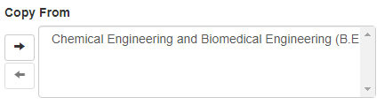
7. Select the destination program and then press the  button under the **Copy To** section
   1. This indicates where the data will be copied to
   2. 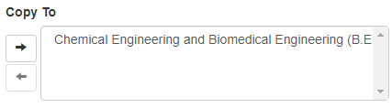
8. Select **No**
   1. [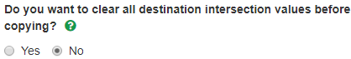](https://user-images.githubusercontent.com/38359810/67124646-f5b7f780-f1c0-11e9-84cc-5111c7be8cb5.png)
9. Select **Yes, make separate copies**
   1. 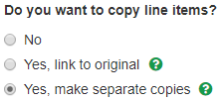
10. Select **Yes**
    1. image
11. Select **Yes**
    1. image
12. Select **Run**
    1. image
13. Go to ETL History to ensure the job is complete
    1. 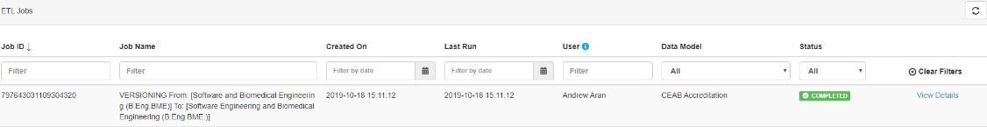

## Measured Indicators

The measurement map for each year identifies what needs to be measured for that year.

A Department Representative will contact the Administrator when a change is required.

Before making a change, obtain approval from the Associate Dean’s Office.

### Opening the Measurement Mapping

1. Under Manager view, select **Accreditation 2.0**

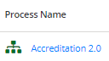

1. On the left side, select **Files Library**



1. Select **Input Forms**
2. Download the Measured Indicators Template.xlsm file



1. A pop-up will appear to save the template. Click **save** and remember the saved location of the template.
2. Open the Excel File
   1. If prompted, press **Enable Editing** in the Excel spreadsheet



* 1. If prompted, press **Enable Content** to allow Macros



1. Select the Program, Year, and press OK

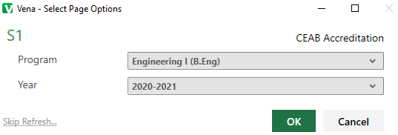

### Updating the Measurement Map

**\*\*\*The measured indicators map should only be updated for the current year\*\*\***

The measured indicator map is centralized at the program level, and it is using the previous year’s information as the starting point for the current year. Therefore, some of the information may be prepopulated.

* 1. **Adding an indicator**: If an indicator for a course needs to be measured for the year, place an **M** in the cell intersecting between the indicator and course

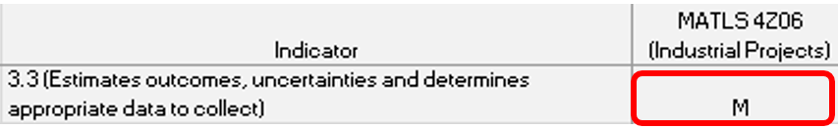

* 1. **Removing an indicator**: Before removing a measured indicator from a course, be sure to FIRST delete ALL the line items pertaining to the indicator in the Rubric Input Template.

For the current year, you’ll need to check all sections (1-10) for each term (1-3) and ensure there is no rubric data pertaining to the indicator.

Once it is confirmed that there is no data pertaining to the indicator, delete the **M** in the cell intersecting between the indicator and course

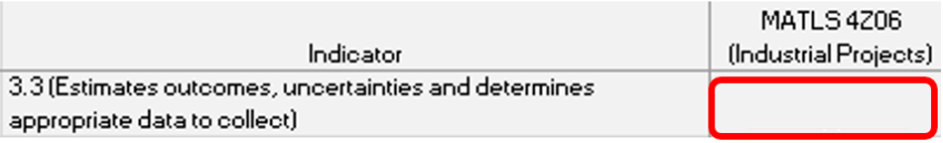

Note: When an **M** is placed between an indicator and course, the indicator will be available in the Rubric Input Template and enable users to enter learning outcomes (rows) for that indicator. To learn more about the Rubric Input Template, please review the Instructor Guide.

|  |  |
| --- | --- |
| **Example:** Measured Indicators Template updated to display the indicator in the Rubric Input Template | |
| **Measured Indicators Template** |  |
| **Rubric Input Template** |  |

1. When the indicators have been updated, click **Save Data** under the **Vena Tab**

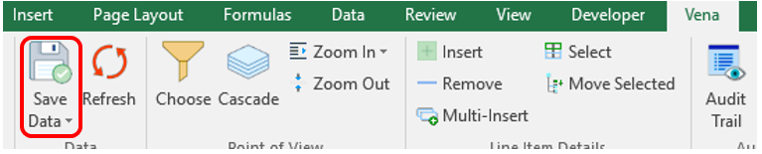

1. Closing and Checking in the Template
   1. When closing the template, you will be prompted to **Check-in**
   2. Select **Yes**

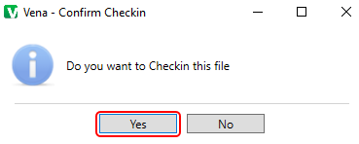

## Cascade

The cascade feature enables users to generate the same Vena report for multiple courses or programs. This feature eliminates the need to manually generate the same report for multiple courses/programs.

### Generating a Mass Course Report

The steps below will show how to create

1. Select Contributor → Reports → Course Reports → **View**
2. Download and open the Course Report
   1. Click **Enable Editing** and **Edit Content** if the pop-up appears
3. Select a Course (belonging to the program), Year, Term, Section
4. Select the Vena Tab then click **Cascade**



1. For dimension, select **Program**

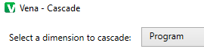

1. Select the courses belonging to the program (hold shift + click)

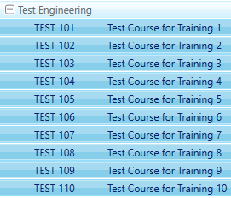

1. Change option from Cascade to Sheet to **Cascade to File**



1. Choose a location to save the files
2. Click **OK**
3. The Cascade feature will take approximately 5-10 minutes to complete

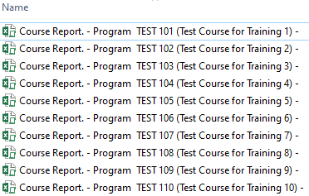

## Force Check-In

Occasionally, a template can be checked out by a user and forgets to check it back in. See the steps below for checking a template back in on behalf of the user.

1. If a template is checked out, try to contact the user, and request them to check the template back in
2. If the user is unable to check in the template, a “Force Check-In” is required
   1. Manager 🡪 Home 🡪 Accreditation 2.0
   2. On the left-hand side, select **Status Tracker** 
   3. Search for the template(s) that is currently checked out
   4. On the right-hand side, select **Task Actions** 
   5. Select **View Checkouts** 
   6. Select the user by clicking the box next to their name
      1. To select all users, click the box at the top row
      2. 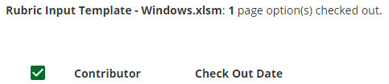
   7. Click **Force Check In** 
   8. A pop-up will appear confirming the template has been successfully checked in 

## Unsubmit

If a task is inadvertently submitted, it is possible to “unsubmit” it. This is done by first pausing the process, then going to the status tracker. Right-click the submitted task and select the Reset Option. After this, the process must be unpaused.

## CourseList – Rubric Input Template

When a course is updated, added, or removed, the CourseList sheet in the Rubric Input Template will need to be updated as well. The CourseList sheet is responsible for validating the course name, term, and section against the Vena database. If there is a discrepancy, the rubric input template will display an error message to the user.

### Updating the CourseList

The following steps will need to be completed as a Vena Manager. Only the Vena Manager has the capability to update the template for all users.

**\*\*\* Vena Manager mode can only be accessed by a Windows-based operating system \*\*\***

1. Under Manager view, select Home 🡪 **Accreditation 2.0**

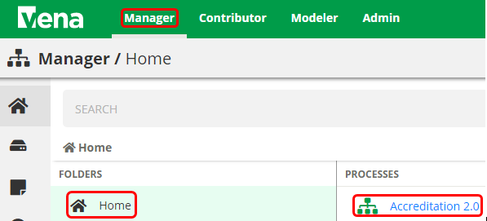

1. On the left panel, select **Files Library**

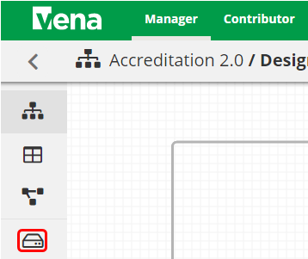

1. Select **Input Forms**

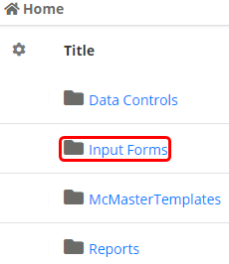

1. Updating the **Windows and macOS Rubric Input Template**

When updating the course information, both templates will need to be updated.

* 1. Select **Rubric Input Template – Windows.xlsm**



* 1. A pop-up will appear to save the template. Click **save** and remember the saved location of the template.
  2. Open the Excel File
     1. If prompted, press **Enable Editing** in the Excel spreadsheet



* + 1. If prompted, press **Enable Content** to allow Macros



* 1. Select a Course, Year, and Section
     1. The choices selected will not matter since we will be updating the template
  2. Right-click the **Outcome_Measurement** sheet 🡪 select **Unhide** 🡪 select **CourseList** 🡪 select **OK**

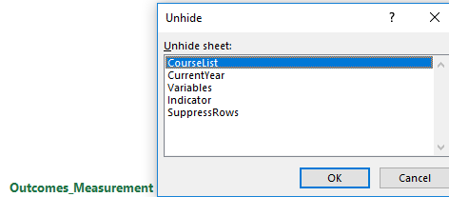

* 1. Update the **Course**; **Term**; **Section** in the spreadsheet (Columns A-C)

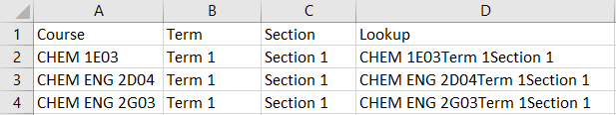

* 1. Copy the Excel formula in **Column D** down
  2. Hide the **CourseList** sheet
  3. Under the Vena tab, click **Save Template**

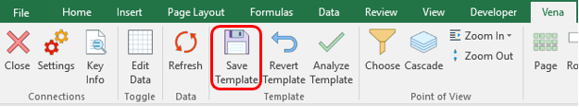

* 1. Close the **Rubric Input Template**

Repeat steps 1-4 for **macOS Rubric Input Template**

## Updating Courses & Program Maps

**Consult with the Associate Dean’s Office and affected department(s) before making any changes to a course or program in Vena.**

This section will demonstrate how to update Vena’s program and course structure to reflect the [Undergraduate Academic Calendar](https://academiccalendars.romcmaster.ca/).

Example: Undergraduate Calendar for Engineering 1 and Vena’s Program Mapping for Engineering 1

|  |  |
| --- | --- |
|  |  |

The courses and programs are updated annually when the latest Undergraduate Calendar is available (usually at the beginning of the Fall Term).

Note: When receiving a request to update a course,

1. If the course already exists, but the name or unit has changed, ask the department if they prefer a new course to be created or update the existing course name/unit. By updating the course name/unit, we keep the historical data for that course.
2. If it is confirmed to be a new course, add the new course to the appropriate program(s).

### Adding a New Course

New courses are added to Vena as they are offered, but courses that are no longer offered **should not be deleted**. They can be unmapped from the program map, but if the course is deleted, **all the associated historical data will be lost.**

1. Under the Modeler View, select **CEAB Accreditation** 🡪 **Members** 🡪 **Program**

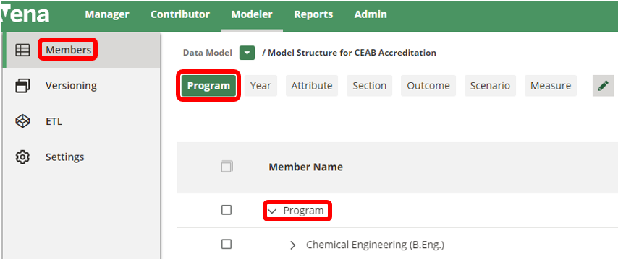

1. Expand the **Program List** 🡪 Expand the program where the new course will be added 🡪 Expand the **Level**  🡪 Right-click on the level 🡪 Select **Add Child**

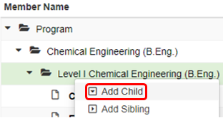

1. Enter the **Course Code** and **Description**
   1. Once a course has been added, remember to update the Measured Indicators Input Template

### Sharing a Course

A course can be shared if the course already exists in Vena and needs to be added to another program.

1. Under the Modeler View, select **CEAB Accreditation** 🡪 **Members** 🡪 **Program**



1. Select the course to be shared:
   1. Expand the **Program List** 🡪 Expand the program 🡪 Expand the **Level**  🡪 Right-click on the course 🡪 Select **Share**

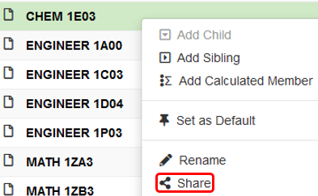

1. Next, select the destination:
   1. Expand the **Program List** 🡪 Expand the program 🡪 Expand the **Level**  🡪 Right-click on the level 🡪 Select **Paste**

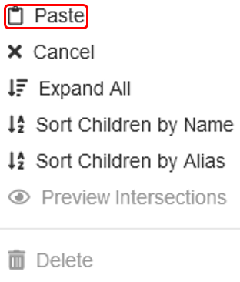

### Un-mapping a Course

Un-mapping a course is essential when the course is no longer offered for a program or multiple programs. This prevents users from accidentally submitting data into the un-mapped course.

#### How to Un-map a Course

If the course is no longer offered, the course is un-mapped and moved to the “Unmapped” folder. When the course is moved to the “Unmapped” folder, historical rubric data will remain available, but rubric data can no longer be submitted or edited for that course.

1. Pause the Process
   1. Under the Manager View, select **Accreditation 2.0**, press the **Pause** button

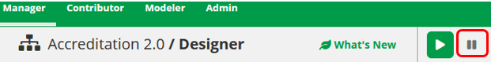

1. Under the Modeler View, select **CEAB Accreditation** 🡪 **Members** 🡪 **Program**



1. Cut and paste the course to the “Unmapped” folder
2. Expand the **Program List** 🡪 Expand the program 🡪 Expand the **Level**  🡪 Right-click on the course 🡪 Select **Cut**

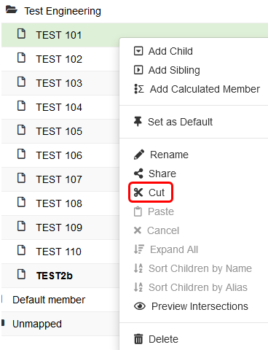

1. Expand the **Unmapped Folder** 🡪 Select and expand the **Unmapped Academic Year** (this is the year the course has been un-mapped) 🡪 Select and expand the program it was un-mapped from 🡪 Right-click the **Level** it was un-mapped from 🡪 Select **Paste**

Note: You may need to create the un-mapped program or level folder if it does not exist.

Repeat steps 1-3 until the un-mapped courses have been moved to their designated “Unmapped” folder.

## Reports

The data in the MEASURE database is viewed using Microsoft Excel. The data uploaded to Vena is used to generate reports. The Vena Reports are best viewed using a Windows-based operating system.

### Accessing the Reports

1. Ensure the Contributor tab is selected

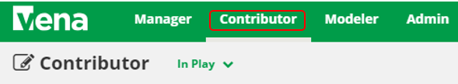

1. On the left side, click **Reports** (the centre section will reload to only display Reports)

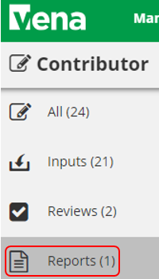

1. Click **Reports**

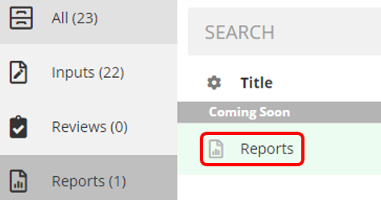

### CEAB Annual Attribute Report

This multi-page report provides a detailed snapshot of how the program is progressing for the current year. It includes an overall program summary and a separate report for each Graduate Attribute at the course level.

The report is built off a calculated average with a set order of operations, rather than directly based on the average of total students per outcome. At each level, the total is aggregated. For example, at the Section level, all sections are aggregated together, and from there, all terms are aggregated together to get a Yearly Average for all Sections per Course.

The order of operations for the calculation is:

1. LID’s (Learning Outcome)
2. Indicator
3. Attribute
4. Section
5. Year
6. Program

#### Viewing the Annual Attribute Report

1. Select **View** next to **CEAB Annual Attribute Report.xlsm**
2. **Save** and **open** the Excel file
   1. If prompted, **Enable Content** and **Enable Macros**
3. Select the **Program** and press **OK**

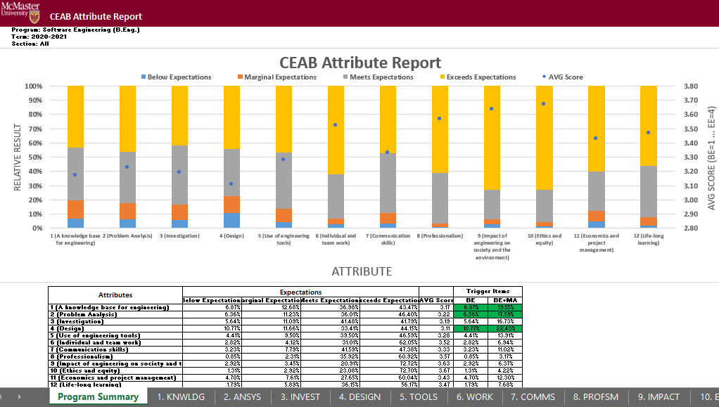

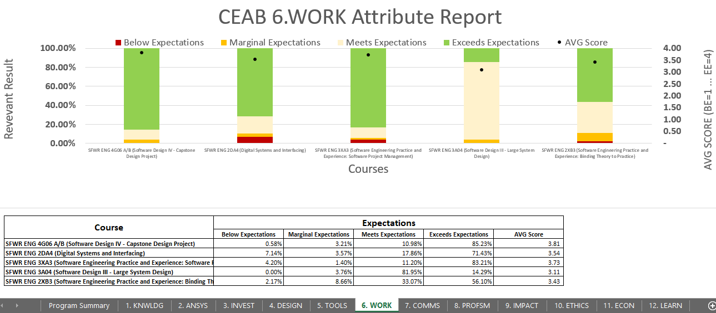

### CEAB YoY (Year over Year) Attribute Report

This report provides a look into the Average Score per Attribute, at a Program level, comparing it year over year. The Choose option that pops up allows you to choose the ending year that you’d like to view.

Prior to 2020-2021, the previous average scores were calculated based on the archived data of the # of students in each attribute/outcome. Starting in 2020-2021, the calculation is calculated on the new average process, as detailed in the CEAB Attribute Report section above.

The data for the current year, or most recent year is not automatically calculated. This YoY report uses archived data as it’s source. As a result, the archiving process must be executed to see the current year data. Note that this means the entire process must be completed, and the data from step 7a of the Vena Template Automation Average ETL must be executed. This is imperative to the process.

Please refer to the One Time Fix – ETL section of the CEAB Attribute Report.

#### Viewing the YoY Attribute Report

1. Select **View** next to **CEAB YoY Attribute Report.xlsm**
2. **Save** and **open** the Excel file
   1. If prompted, **Enable Content** and **Enable Macros**
3. Select the **Program**, latest **Year**, and press **OK**

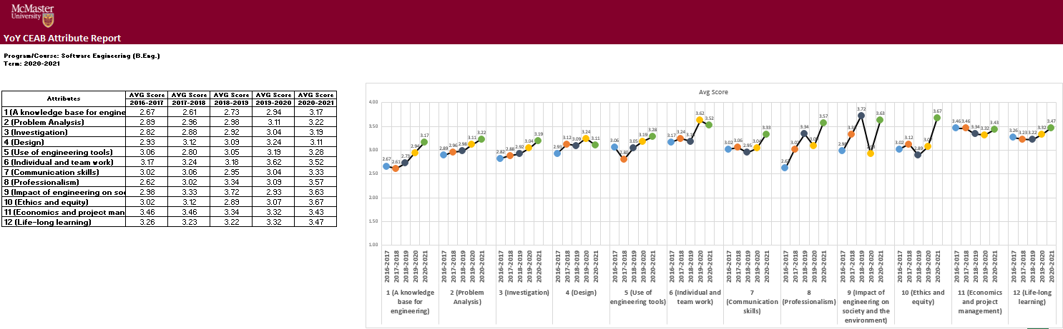

### Maintaining the CEAB Attribute Reports

#### Updating the CEAB Attribute Report Data

The annual data for the report is updated nightly, however, if in the middle of the day, the data requires an update after making changes, a Modeler access individual must make updates. To update the data, you will need Modeler access to run the ETL job “Vena Template Automation Averages”.

The YoY data is updated manually with Vena’s Archive ETL.

1. Select the **Modeler** tab 🡪 Data Modeler 🡪 ETL 🡪Templates
2. Press **Run** next to **Vena Template Automation Averages**
   1. 6-step ETL process to normalize the data and generate the Annual Report
3. Press **Import**
4. Once the process is complete, perform a template data save for the YoY Average scores. This is currently a workaround because Vena is unable to save the YoY Average scores via ETL. They confirmed it is a production issue and are reviewing it (as of April 2021).
5. Select the **Manager** tab 🡪 Accreditation 2.0 🡪 Files Library 🡪 Input Forms 🡪 Vena TA
6. Download and open Step 7a: McMaster Accreditation Averages TA - Average Scores by Attribute.xlsx
7. If prompted, **Enable Content** and **Enable Macros**
8. In Excel, select the **Vena** tab
9. Press **Edit Data**
10. Press **Save Data**
11. Close the Template
12. Go back to the ETL page and press **Run** next to Vena Archive ETL
    1. This ETL process updates the YoY data

This process takes approximately 15-30 minutes. Following that, all the data should be up to date.

#### Adding or Removing Courses/Programs

In the event a user must add a course, there are no changes to be made. If, however, a new program is added, with a new set of courses, a new bottom level member must be created. In the Modeler, in the Program dimension, under the “Unmapped” member, there is a folder called “Bottom Level – All”, as in the photo below.

Once here, create a member, matching the EXACT spelling, with the brackets and alias of the Program name, and have “Bottom Level – “, precede the program. Once that is created, there should be no issues.

#### One Time Fix - ETL (After 2020-2021 Year)

Following 2020-2021, Step 7 must be added to the ETL. To do so, from the Modeler tab, in the ETL, click the pencil icon to the left of the “Vena Template Automation Average”.



After adding clicking the icon, replicate the photo below through the dropdowns:

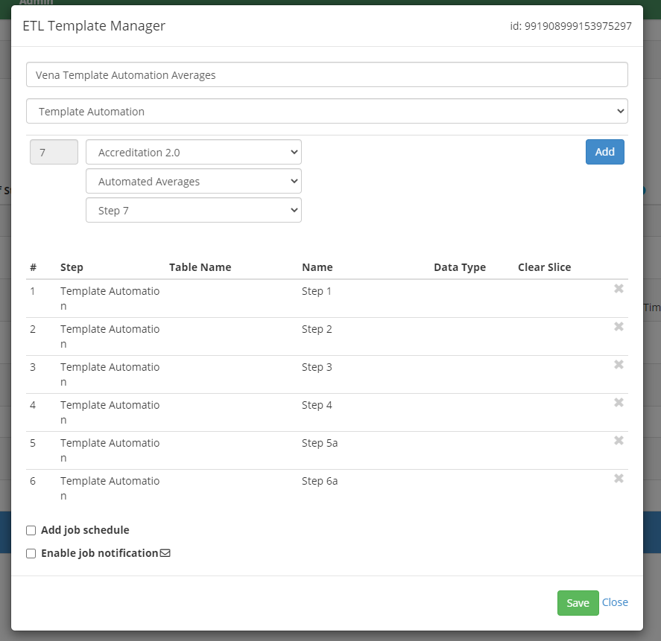

Click the “Add” button on the right and save. This adds a step to calculate the averages for the year.

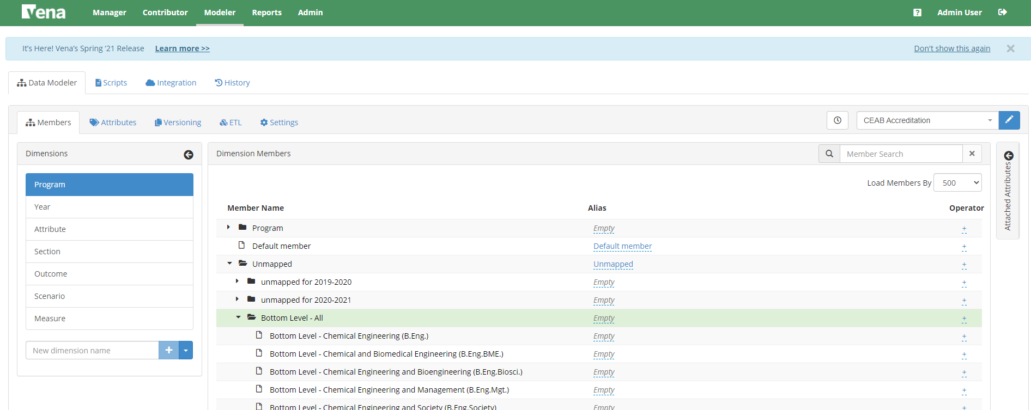

### Rubric Entry Report

The Rubric Entry Report monitors the progress of the rubric input. The report lists all the courses from a selected program. The report will display:

|  |  |
| --- | --- |
| **Column Name** | **Description** |
| Course | * Course name |
| Status | * Displays the current status of the rubric input   + Options: BLANK, Not Started, WIP, Fully Complete |
| Measure Required? | * **If Yes**: At least (1) graduate attribute for a course is being measured for the year * **If No**: The course does not have any graduate attributes measured for the year |
| Instructor Name | * Name of instructor teaching the course |
| Rubric Updated By | * The last user to update the rubric input template for the course |
| Last Rubric Save Time | * The last time the rubric input template was saved |

1. Press **View** next to CEAB Attribute Report
2. Select a Program, Term, and Section
3. **Download** and remember the saved location of the report
4. If prompted, **Enable Content** and **Enable Macros**

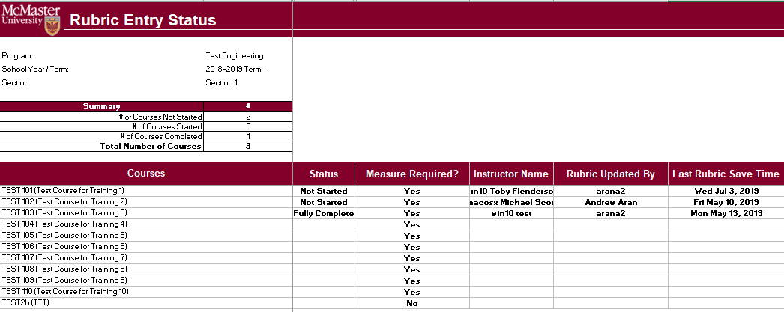

### Faculty and Curriculum Committee Recommendations Report

Displays the recommendations from the curriculum committee at both course and program level. This report can be viewed for any year where data is available. The data comes from the feedback provided in the Curriculum Committee Recommendations Input Template.

1. Press **View** next to Faculty and Curriculum Committee Recommendations Report
2. Select a Course/Program and Year
3. **Download** and remember the saved location of the report
4. If prompted, **Enable Content** and **Enable Macros**

To view an attached file:

* 1. Select the cell containing an attachment

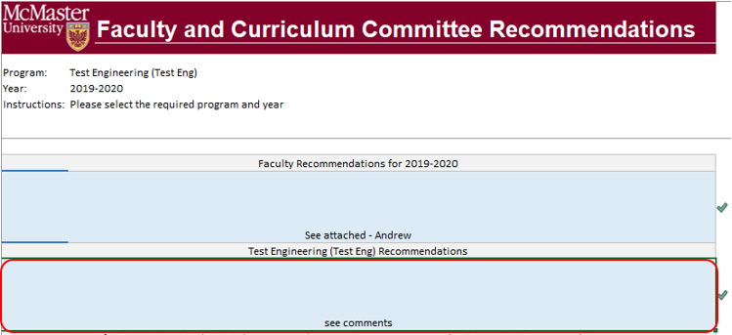

* 1. Click on **Comments** under **Vena** Tab
  2. On the right-hand side, select the attached file

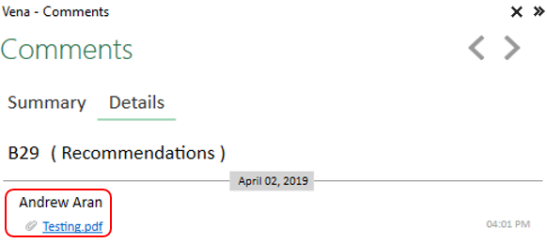

1. For macOS users, click  under Vena Comments
   1. On the right-hand side, select the attached file

### Attribute Map Report

Indicates the measure level at the attribute level. If a different indicator level appears, the highest level will appear: I(ntroduced) 🡪 D(eveloped) 🡪 A(pplied)

1. Press **View** next to Attribute Map Report
2. Select a Program and Term
3. **Download** and remember the saved location of the report
4. If prompted, **Enable Content** and **Enable Macros**

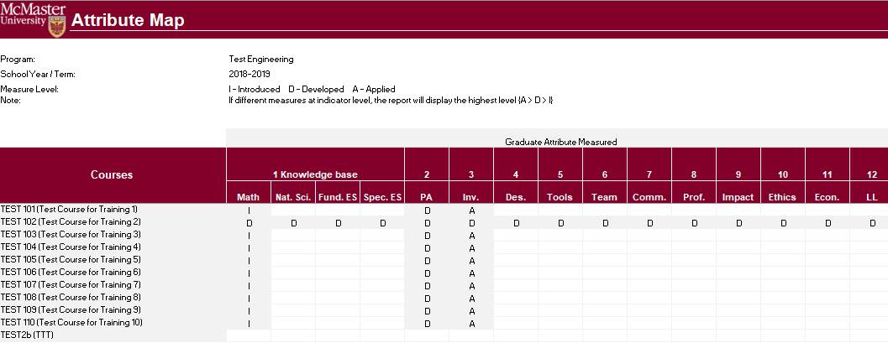

### Attribute Map Summary Report

Similar to the Attribute Map Report, instead of showing the actual level (I, D, A), the summary report will only display the “X” to indicate that the specific course is measured at the specific attribute.

1. Press **View** next to Attribute Map Summary Report
2. Select a Program and Term
3. **Download** and remember the saved location of the report
4. If prompted, **Enable Content** and **Enable Macros**

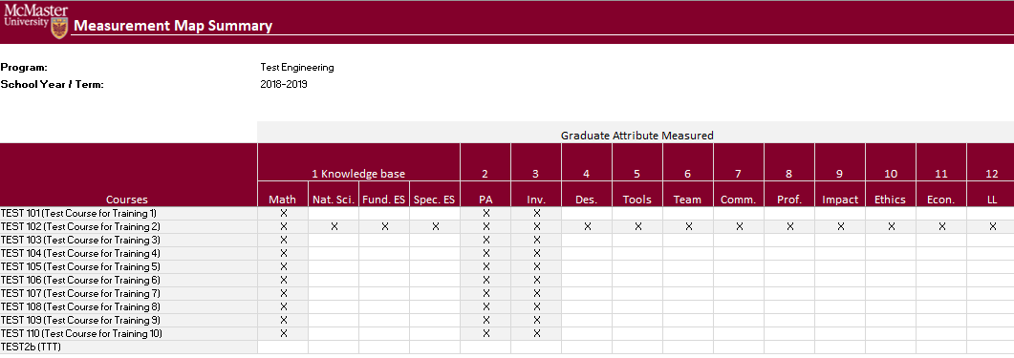

### Indicator Map Report

Indicates the measure level at the indicator level.

1. Press **View** next to Indicator Map Report
2. Select a Program and Term
3. **Download** and remember the saved location of the report
4. If prompted, **Enable Content** and **Enable Macros**

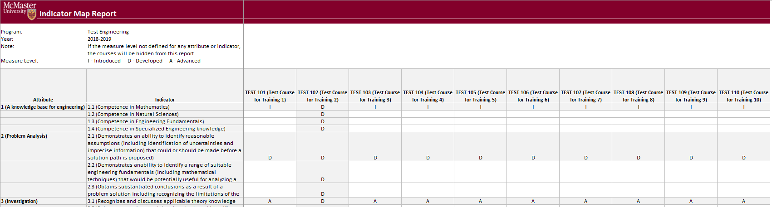

### Historical Course Measurement Report

Shows the historical trend for each course at different levels (indicator, attribute and all).

1. Press **View** next to Historical Course Measurement Report
2. **Download** and remember the saved location of the report
3. Select a Course (and Graduate Attribute if necessary)
4. If prompted, **Enable Content** and **Enable Macros**

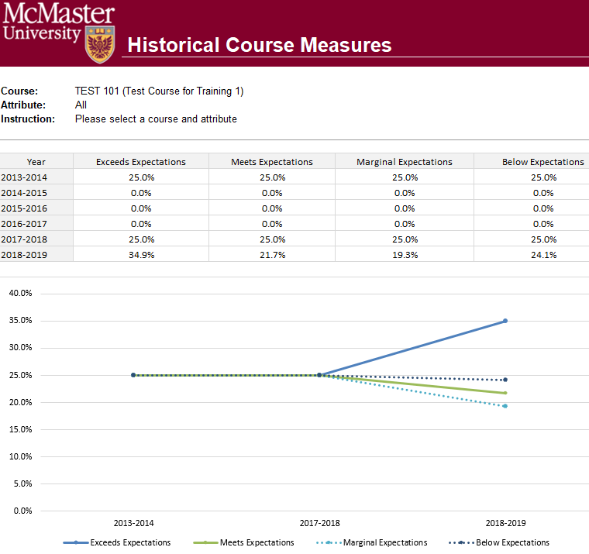

### Historical Program Measurement Report

Shows the historical trend for each program at different levels (indicator, attribute and all).

1. Press **View** next to Historical Program Measurement Report
2. **Download** and remember the saved location of the report
3. Select a Program (and Graduate Attribute if necessary)
4. If prompted, **Enable Content** and **Enable Macros**

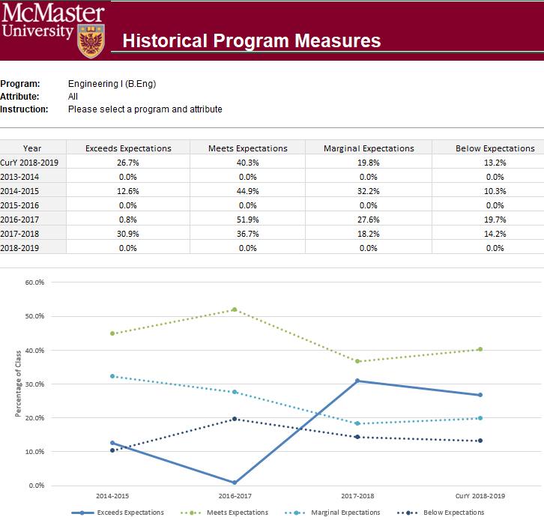

### Course Report

Displays the course outcome, recommendations from the curriculum committee, the continuous improvement plan, and charts generated from the rubric entry. Every course for which rubric data is entered will have a corresponding Course Report.

# Appendix I: Calculating the CEAB Annual Attribute Reports

This section explains the calculations behind the CEAB Attribute Reports.

The order of operations for the calculation is:

1. LID’s (Learning Outcome)
2. Indicator
3. Attribute
4. Section
5. Year
6. Program

## How the Graduate Attribute Values are Normalized

1. User enters and submits their rubric data to the Rubric Input Template
2. Vena completes the following steps with the rubric data:

Step 0: Convert values to %

Step 1: Average LID's by Indicator

Step 2: Average Indicators by Attribute

Step 3: Average Attribute by Section (if course is offered in multiple sections)

Step 4: Average Section by Year (if course is offered in multiple terms)

Sample Calculation with Test Values



1. Results are Outputted to the Annual CEAB Attribute Report

## How the Average Scores are Calculated

* Every Graduate Attribute is measured by (4) Expectations
  + Below (BE), Marginal (MaE), Meets (MeE), Exceeds (EE)
* Each Expectation has a score
  + BE = 1; MaE = 2; MeE = 3; EE = 4
* Formula
  + Average Score for a Graduate Attribute =

(GA% x BE) + (GA% x MaE) + (GA% x MeE) + (GA% x EE)

Example:



# Appendix II: Previous Modification Log

|  |  |  |  |
| --- | --- | --- | --- |
| **Version** | **Modification date** | **Author** | **Comments** |
| 1.0 | July 4, 2016 | Evan Situ |  |
| 1.1 | August 29, 2016 | Evan Situ | Added section 6 and 8 and 1.4 |
| 1.2 | September 13, 2016 | Evan Situ | Added 9. Updating a Global Variable |
| 1.3 | September 16, 2016 | Evan Situ | Added Section 10 Force Check-In |
| 1.4 | September 26, 2016 | Evan Situ | Added 11.Update Course Information Input Template |
| 1.5 | October 20, 2016 | Michelle Zheng | Minor edits |
| 1.6 | November 16, 2016 | Michelle Zheng | Added title page and Section 7 |
| 1.7 | November 29, 2016 | Michelle Zheng | Updated Section 4 |
| 1.8 | December 16, 2016 | Spencer Smith | Changing template property for concurrent contributors |
| 1.9 | January 19, 2017 | Spencer Smith | Clarification of submitting rubric and course reports |
| 1.9.1 | April 19, 2017 | Spencer Smith | Note about protected cells |
| 1.9.2 | April 12, 2018 | Spencer Smith | Addition on adding superuser permissions |
| 1.9.3 | April 18, 2018 | Andrew Aran | Updated screenshots for:   * 4. Add User * 5. Assign User to Process * 7. Faculty Recommendations * 8. Start New Academic Year * 9. Historical Program Measurement Archive * 11. Updating a Global Variable * 13. Update Course Information Input Template |
| 1.9.4 | May 3, 2018 | Andrew Aran | * Updated Global Variable Process * Updated the order of the tasks in the instructions |
| 1.9.5 | October 15, 2018 | Andrew Aran | * Added Contract Renewal Interval to timeline * Added backup and restore interval to timeline |
| 1.9.6 | April 29, 2019 | Andrew Aran | * Added instructions to access CEAB Attribute Report and Drill Down Feature |